

**TECHNICAL UNIVERSITY OF KENYA**

**FACULTY OF APPLIED SCIENCES AND TECHNOLOGY**

**SCHOOL OF COMPUTING & INFORMATION TECHNOLOGY**

**DEPARTMENT OF COMPUTER SCIENCE AND TECHNOLOGY**

**BACHELOR OFTECHNOLOGY (COMPUTER TECHNOLOGY)**

**PROJECT REPORT**

**SHOP INVENTORY MANAGEMENT INFORMATION SYSTEM**

**DAVID WACHIRA GITONGA**

**SCCI/00277/2015**

**SUPERVISOR**

**MR. GITAU**

# 

# ABSTRACT

Record keeping is not only important but also mandatory for anyone running a business whether big or small. This has been really difficult for small scale business persons due to unavailability of affordable systems to perform the task. The Shop Inventory MIS provides a platform for small scale business traders to perform record keeping and inventory tracking.

This project report has been written and presented upon completion of the analysis and design processes of The Shop Inventory MIS which took eight months at The Technical University of Kenya. This document provides an overview of the tasks taken and some of the steps taken as required by system analysis and design, implementation as well testing of the system before it is rolled out for use.

The development tools used have been highlighted in this document. The database and its functionalities have also been addressed in detail. Data collection and modelling as well as the challenges faced and recommendations for this system have also been aired and provide an overview of the complete development process.

This project report is a requirement as part of the fulfilment for the award of the Bachelor of Technology Degree in Computer Technology and mainly focuses on the concepts that have been learnt and applied within this course.

# DECLARATION

This project is my original work and to the best of my knowledge, it has not been presented for any academic award in this university or any other.

**DAVID WACHIRA GITONGA**

**SIGNATURE………………………………………….**

**DATE…………………………………………………**

**SUPERVISOR:**

**Mr. GITAU**

**SIGNATURE……………………………………….**

**DATE………………………………………………..**

# ACKNOWLEDGEMENT

I would wish to appreciate my supervisor for the continued support in coming up with this project. Special thanks to all my friends who have helped me in all struggles to make it happen. Above all, I thank the Almighty God for giving me strength, good health and protection, wisdom and knowledge while working on this project.

TABLE OF CONTENT

ABSTRACT 2

DECLARATION i

ACKNOWLEDGEMENT ii

LIST OF FIGURES vi

LIST OF TABLES vii

LIST OF ABBREVIATIONS viii

CHAPTER ONE: INTRODUCTION 1

1.1 Introduction and background 1

1.2 Problem statement 1

1.3 Objectives 2

1.3.1 Major Objective 2

1.3.2 General Objective 2

1.3.3 Specific Objectives 2

1.4 Scope 2

1.5 Justification 3

1.6 Project Risk and Mitigation 3

CHAPTER TWO: LITERATURE REVIEW 4

2.1 Introduction 4

2.2 Small scale retailers 4

2.3 Inventory Management System 6

2.4 Financial Accounting 6

2.5 Existing systems 7

CHAPTER THREE: METHODOLOGY 10

3.1 Introduction 10

3.2 Purpose of the study 10

3.3 Data collection 10

3.3.1 The Questionnaire Survey 10

3.3.2 The Interview Survey 11

3.4 Sampling Design 11

3.5 Contribution of the Study 11

3.6 Implementation 12

3.7 Project Schedule 12

BUDGET 13

CHAPTER FOUR: SYSTEM ANALYSIS AND REQUIREMENTS MODELING 14

4.1 Introduction 14

4.2 Design Objectives 14

4.3 User Requirements 14

4.4 Functional Requirements 15

4.4.1 Register/Create account 15

4.4.2 Login 15

4.4.3 Stock Shop 15

4.4.4 Make sale 15

4.4.5 Get statement 15

4.4.6 Check Inventory 15

4.5 System Modelling Requirements 16

4.5.1 Flowchart 16

4.5.2 Dataflow diagram 17

4.5.3 Use case diagram 18

CHAPTER FIVE: SYSTEM DESIGN 19

5.1 Introduction 19

5.2 System Design 19

5.3 Database Design 20

5.3.1 Conceptual Design 20

5.3.2 Logical Design 22

5.4 User Interface 22

5.5 Entity Relationship 25

CHAPTER SIX: SYSTEM IMPLEMENTATION 26

6.1 Tools used for coding and testing 26

6.2 Hardware requirements 26

6.3 Software requirements 26

6.4 Coding 27

6.4.1 Programing Language 27

6.4.2 Database 27

6.5 System test plan 27

6.6 Test types 27

6.6.1 Functional Test 27

6.6.2 Unit Test 27

6.6.3 System Test 28

6.6.4 Integration Test 28

6.6.5 Regression Test 28

6.7 Proposed changes over techniques 28

6.7.1 Direct Changeover 28

6.7.2 Parallel Running 28

CHAPTER SEVEN: LIMITATIONS CONCLUTIONS AND RECOMMENDATIONS 29

7.1 Limitations 29

7.2 Conclusion 29

7.3 Recommendations 29

REFERENCES 30

APPENDIX 32

Interesting Codes 32

Mypdf.php 32

Sale.php 41

sms.php 52

# LIST OF FIGURES

Figure 1: Shop Inventory MIS Project Gantt chart 12

Figure 2: Shop Inventory MIS Flow Chart 16

Figure 3: Shop Inventory MIS DFD 17

Figure 4: Shop Inventory MIS Use case Diagram 18

Figure 5: Shop Inventory MIS Architecture 19

Figure 6: Shop Inventory MIS Stock Table 20

Figure 7: Shop Inventory MIS Logical Design 22

Figure 8: Shop Inventory MIS Home Page 23

Figure 9: Shop Inventory MIS My Shop Page 23

Figure 10: Shop Inventory MIS LogIn Page 24

Figure 11: Shop Inventory MIS Profit and Loss Statement 24

Figure 12: Shop Inventory MIS Entity Relationship 25

# LIST OF TABLES

Table 1: Shop Inventory MIS Budget 13

Table 2: Shop Inventory MIS Conceptual Design 20

# LIST OF ABBREVIATIONS

MIS…………………….. Management Information System

SMS…………………….. Short Message Service

SDLC……………………. Software Development Life Cycle

RDBMS………………….. Relational Database Management System

HTML…………………….. Hyper Text Markup Language

CSS………………………... Cascading Style Sheets

PHP……………………….. Hypertext Preprocessor

UI………………………… User Interface

IDE………………………….Integrated Development Environment

RAM……………………… Random Access Memory

# CHAPTER ONE: INTRODUCTION

## Introduction and background

A business is an organization or economic system where goods and services are exchanged for one another or money. Business persons engage in business activities in order to make profit through which they make their livelihood.

According to an article “Why should I keep records” on the IRS website, keeping good records helps the business persons; monitor the progress of their business, prepare financial statements, identify their sources of income, keep track of their deductible expenses, prepare tax returns and support items reported on their tax returns all which are very important for any business.

Currently, record keeping for small businesses such as retail shops involves filling of the data in ledger books and journals for every sale and purchase. Analysis is also done manually using the books. The data is analyzed to prepare reports such as income statements and balance sheets. This processes especially data analysis is difficult and there are very high chance of error.

Some small-scale business persons find this process too difficult as others don’t find it important and hence don’t do it at all

## Problem statement

It would be ideal for shop keepers/owners to have proper records which will facilitate monitoring of business progress and financial reporting. In this situation business owners will be able to keep track of their income, expenses and even tell whether they made profits of losses.

Currently, keeping track of business progress is a difficult manual task which some small-scale shop owners even ignore. This causes business owners to sometimes operate in losses without their knowledge, they are also forced to add more capital into the business (sometimes in form of loans) which only helps the business stabilize for a short time, the business then falls back to its former state. Apart from keeping financial records, studying of the market (finding out which product sells most and when) is also not easy. This causes the investors to stock blindly which does not give optimum production.

The proposed system will be very effective in managing the business operations for small businesses especially sole proprietorships including hawkers.

## Objectives

### 1.3.1 Major Objective

The main goal of this project is to ease the work of data recording and analysis for owners of small businesses.

### 1.3.2 General Objective

To develop a web application that automates data recording and analysis for the owners of small businesses.

### 1.3.3 Specific Objectives

* To provide users with an interface through which they can stock their shops (they can either add new items or update the quantities of already existing items).
* To provide users with an interface for recording sales.
* To design an interface through which users can track their stock. They will be able to tell how much stock they have left at any point of time.
* To create an interface that allows user to view, download and print profit and loss statements.
* To send users SMS alerts when they are almost out of stock.

## Scope

The project aimed at meeting the said objectives by creating a web application that allows users perform sales recording, stock updating and preparation of profit and loss statements. The system will also give users SMS alerts when they are almost out of stock.

For users to perform the above functions, they will be required to have accounts in the system and their details used for authentication.

## Justification

It is important that shop keepers have a software system for record keeping and inventory tracking.

This system gives the shopkeepers an interface for easy record keeping and analysis of data such as; stock sold, available stock, amount of profit made, amount of loss made, etc. The data analysis will be facilitated by the income statement that will be generated using the system and information obtained from querying the database for stock details.

According to (Experian Information Solution Inc, 2018) “You need good records to monitor the progress of your business. Records can show whether your business is improving, which items are selling, or what changes you need to make. Good records can increase the likelihood of business success.”

The shop inventory MIS system provides a cheap and simple way for shop keepers and business owners to meet the above objective.

## Project Risk and Mitigation

* Inadequate human resources to develop system

Only one developer is available to work on the project within the available three months. Delay to complete the project on time will be very counter-productive and may cause the project to miss the presentation deadline.

To meet this constrain, the programmer will be required to start development earlier than expected in order to meet the project deadline.

# CHAPTER TWO: LITERATURE REVIEW

## 2.1 Introduction

A business is an organization or economic system where goods and services are exchanged for one another or for money. Every business requires some form of investment and enough customers to whom its output can be sold on a consistent basis in order to make a profit.

For the business to make consistent profit, it is important to constantly analyze its progress which allows owners to plan for the future. This calls for the application of financial accounting (which is a specialized branch of accounting that keeps track of a company's financial transactions). Through financial accounting, business transactions are recorded, summarized, and presented in a financial report or financial statement such as an income statement or a balance sheet. These reports are then used in the analysis process since they are easy for the business owners to understand. For effective accounting every income and expense must be recorded (in time) to avoid errors. Stock/inventory tracking is also very important in facilitation of the monitoring of business progress.

The proposed system intends to provide small scale retailers with an interface for easy recording of their products, sales and to automatically generate income statements which they can use to monitor their progress.

## 2.2 Small scale retailers

Small scale retailers are also called fixed shop retailers. They run small shops that deal with miscellaneous products of daily use and shops that sell particular products of various varieties. They have fixed shops of their own and hold small stock and are located in market areas and residential places. They are popular in both urban and rural areas.

Small scale retailers are effective since they are close to the consumers.

Small scale retailers with shops include: -

* Single shops

Single shops are mostly located in the trading or market centers in rural areas or in the residential areas of high towns and are operated from fixed premises

They are usually run by one person who may get assistance from him/her family or employ attendance.

Some deal in one line of commodity such as houses, clothing, groceries or electronics

* Tied shops

These are shops that mainly sell the products of one particular manufacture or are owned by a specific supplier of certain goods. The shops are owned or controlled by the manufacturer, and are thus tied to the manufacture. The manufacture/supplier designs the organization of the shop and its appearance e.g. painting hence they look alike. The supply closely supervises the shops.

* Kiosks

A kiosk is a small, enclosed stand from which merchandise is sold, often placed in the common area of a shopping center or public concourse.

They deal in fast-moving items and groceries such as; sodas, cakes, sweets, cigarettes and newspapers.

* Mobile shops

Mobile shops, like itinerant traders move from town to town or village to village selling their goods.

They have vehicles that they have converted into a shop from which customers can buy their goods and they visit different towns at regular intervals.

* Market stalls

​These are permanent stands found in market places, especially those operated by the various local authorities. They are of different designs depending on the goods they sell or services they offer

They are rented or leased by individuals from local authorities  
They deal in fast moving household goods though some may specialize in other products such as clothing and shoes.

* Canteens

These are retail shops found in institutions such as schools, colleges, hospitals and army barracks.

They stock a variety of consumable goods such as sodas, bread, tea, groceries and other things used by the people in that institution.

They are run by the institutions management or by individuals on retail business.

## 2.3 Inventory Management System

This is a database used for storing and administering all types of data required for efficient and accurate inventory management. This may include modules or fields for keeping track of all items and locations, requisitions, back orders, required levels of inventory on hand, reorder points, lead times inventory order tracking and more.

## 2.4 Financial Accounting

**Financial accounting** is a specialized branch of accounting that keeps track of a business’ financial transactions. Using standardized guidelines, the transactions are recorded, summarized, and presented in a financial report or financial statement such as an income statement or a balance sheet.

Businesses issue financial statements on a routine schedule. The statements are considered *external* because they are given to people outside of the company, with the primary recipients being owners/stockholders, as well as certain lenders. If a corporation's stock is publicly traded, however, its financial statements (and other financial reports) tend to be widely circulated, and information will likely reach secondary recipients such as competitors, customers, employees, labor organizations, and investment analysts

It's important to point out that the purpose of financial accounting is not to report the value of a company. Rather, its purpose is to provide enough information for others to assess the value of a company for themselves.

## 2.5 Existing systems

Accounting software is a type of computer software used by accounting professionals to manage accounts and perform accounting operations.

They offer interfaces for recording financial information and generation of reports.

Examples of existing accounting and Inventory management systems include: -

1. Odoo

ODOO, formerly known as OpenERP (Enterprise Resource Planning), is a platform that companies can use to easily manage the basics of the company such as materials and warehouse management, human resources, finance, accounting, sales and many other enterprise features.  
This is being done by means of an intuitive user interface that can be easily extended with community modules or with customized modules that suit the client's purposes. Helping you make smart decisions every day, ODOO can be used by companies of all sizes, offering a clear and integrated view of your business

1. Quickbooks

This is an accounting software with the following features;

* Cloud Accounting - Access your account, manage your business, and stay organized anytime, anywhere on your computer, mobile or tablet.
* Expense Tracking - Record expenses for tax time. You can even photograph and save receipts with the QuickBooks Online mobile app.
* Invoicing - Create custom, professional invoices, sales receipts and estimates that you can send in minutes
* Accounting Reports – Helps users see how businesses are performing with customizable reports and dashboards.
* Cash Flow Management – allows users to enter bills from vendors, and pay them only when they are due. Schedule recurring payments to save time.
* Accountant access - Your accountant can manage your records from anywhere, anytime making it easy to work together.
* Automatic backups - QuickBooks Online backs up your data every day, so your figures are always up-to-date.3
* Data security - Bank level security (128-bit SSL encryption) ensures your data is safe.4
* Free unlimited support - If you need help, support is available Monday to Friday 7.00 am -   
  12.00 am (GMT+8).5

1. Tally

Tally is a powerful yet easy to use accounting program for both small and large businesses. It was developed in India in 1998 and has more than 1 million customers worldwide. It's widely used across all industries, including education, health care, retail and hospitality.

Business owners can choose from different types of software programs depending on their needs. Tally ERP 9, for instance, is Tally's main product. It features single and multi-user licenses and can handle a wide range of tasks, from payroll and tax management to accounting and resource planning. This intuitive software program was launched in 2009. (Picincu, 2018)

1. **Nextar POS Supermarket Software**

Nextar POS is a complete system designed to simplify your routine: track sales, optimize inventory control, speed up the checkout process and improve your business strategy with custom reports.

Nextar helps the business in the following ways; Point of Sale, Cash Register Control, Multiple Terminals, Barcode Scanning, Statistics and Reports and Stock Management. (Nextar, 2018)The proposed system aims at helping users (small scale retailers) record their daily transactions (sales, purchases) and generate income statements for customized periods.

1. **Zoho Inventory**

This is an inventory management system developed by Zoho Corporation, which is a California based company.

It enables businesses to automate their order and inventory management, and track deliveries.

# CHAPTER THREE: METHODOLOGY

The methodology that were applied by the study were chosen in order to acquire information and deduce conclusions about the running of small-scale retail shops in Kenya. It also aimed at giving a proposed solution to the problems experienced in this area.

## 3.1 Introduction

This chapter deals with defining the resources, techniques and means necessary for the implementation of the Shop Inventory MIS.

## 3.2 Purpose of the study

The main purpose of this study is to obtain an insight into the current working condition of small scale retailers in relation to record keeping, stock tracking and financial accounting. The study focused on how shop keepers/ business owners spend, record and reported on their finances and stock.

## 3.3 Data collection

In order to achieve the objectives of this research, primary data was collected and analyzed. Data collection was done in the following ways:

1. An online questionnaire survey was conducted targeting shop keepers in urban areas.
2. Interviews with shop keepers and business owners.

### 3.3.1 The Questionnaire Survey

A questionnaire is a research instrument consisting of a series of questions for the purpose of gathering information from respondents.

For this study, a questionnaire with both closed and open-ended questions was designed to call for response. The closed ended questions narrowed down the responses since the respondents had to choose from a specific pool of responses while the open-ended questions gave rich qualitative data since they allow the respondents to elaborate on their answer.

The questionnaires was designed to gather information about how shop keepers and business owners record their income and expenses, whether/how they report on the data and whether/ how the analyzed data helps the business.

### 3.3.2 The Interview Survey

A personal interview survey is a survey method that is utilized when a specific target population is involved. The purpose of conducting this survey is to explore the responses of the people to gather more and deep information.

This technique is used to probe the answer of the respondents and at the same time to observe their behavior.

For the purpose of this study, face to face interviews were conducted involving two interest groups: business owners and shop keepers. The choice was based on researcher’s knowledge about different educational levels among interviewees, their different lifestyles and ages.

## 3.4 Sampling Design

In order to conduct this research effectively, a sample of the population must be selected to represent the whole. An ideal situation would allow one to survey the whole population, however, this will not be possible for our study.

The questionnaire technique was be used to collect primary data. For the purpose of this study, random probability sampling will be used.

The Interview technique was also be used. The sample population for the interviews will include shop keepers and business owners in Bahati town ship in Nakuru North District.

## 3.5 Contribution of the Study

The findings of this study were used to develop a new solution to the current problems facing business owners and shop keepers for small-scale retail shops.

## 3.6 Implementation

The implementation of the Shop Inventory MIS system applied the *waterfall model* of the Software Development Life Cycle (SDLC). In this model, progress is seen as flowing steadily downwards (like a waterfall) through the phases of software implementation.

The phases of the SDLC involved in the waterfall model are: -

1. Requirements gathering
2. System Design
3. System development and implementation
4. System Testing
5. Maintenance

## 3.7 Project Schedule

The following was the time schedule for the project.

Figure 1: Shop Inventory MIS Project Gantt chart

## BUDGET

For the Shop Inventory MIS to be developed, the following resources were required;

|  |  |  |  |
| --- | --- | --- | --- |
| **Item** | **Unit Number** | **Unit Price** | **Total Cost (ksh)** |
| Laptop | 1 | 35,000 | 35,000 |
| Internet | - | - | 4,000 |
| PHP Storm IDE | - | - | - |
| Hosting | - | - | 4,200 |
| PHP | - | - | - |
| HTML and Javascript | - | - | - |
| **TOTAL** |  |  | **43,200** |

Table 1: Shop Inventory MIS Budget

# CHAPTER FOUR: SYSTEM ANALYSIS AND REQUIREMENTS MODELING

## 4.1 Introduction

After research which was done through interviews and questionnaires, the need for this system in the small-scale business domain was established. This system will provide an interface for automated recording of sales, purchases and the access of income statements for small-scale business persons. The system has a user-friendly user interface which is clear and easy to use, it is through this UI that users can access all the user requirements.

This chapter describes the functionality of the system both functional requirements and user requirements.

## 4.2 Design Objectives

The Shop Inventory MIS is designed to;

* Allow users register to the system.
* Allow users add to the stock database.
* Allow user query the sold stock database for income statements.
* Allows users record sales through the system.
* Allow users login to the system.

## 4.3 User Requirements

Users should be able to use the Shop Inventory MIS in the following ways;

1. Create user accounts that allow user by inputting the required details.
2. Log into the system by inputting their email addresses and passwords.
3. Get a view of their stock/inventory, both available and already sold stock.
4. Make sales through the system.
5. Get their financial statements

These requirements provide users with information necessary to support their decision-making process.

With the information about inventory and from their financial statements, the users will be constantly informed and up to date on their business progress, and their decisions will always be well informed.

## 4.4 Functional Requirements

### 4.4.1 Register/Create account

This function allows users to create account in the system using their names, email addresses and preferred passwords.

### 4.4.2 Login

This feature allows users log in to their accounts using their email addresses and passwords.

### 4.4.3 Stock Shop

This feature allows users to add items to their stock database by inputting data such as; description, quantity, buying price and selling price. The users can also update the quantity of already existing items through this feature.

### 4.4.4 Make sale

This feature allows shop keepers to make sales using this system.

They can achieve this by clicking on the stocked items and adding them to a cart where the total price is automatically calculated for them. After making the sale through the cart, the items on the cart are added to the sold stock database.

### 4.4.5 Get statement

This feature allows users access to their income statements in terms of periodic or on demand statements.

### 4.4.6 Check Inventory

This feature allows user their inventory/stock details at any given time.

## 4.5 System Modelling Requirements

The following models were made to describe the system.

### 4.5.1 Flowchart

This is the Shop Inventory MIS Flowchart

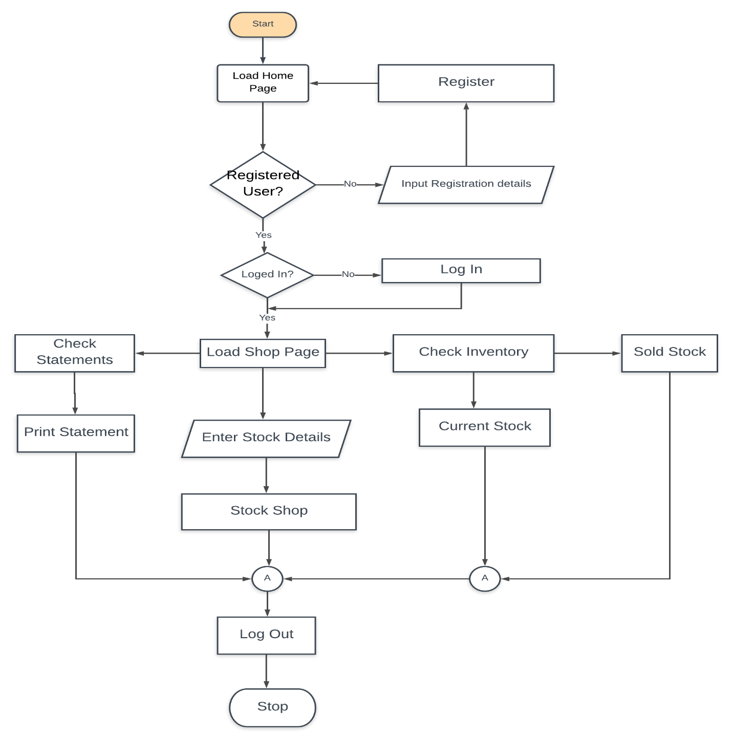

Figure 2: Shop Inventory MIS Flow Chart

### 4.5.2 Dataflow diagram

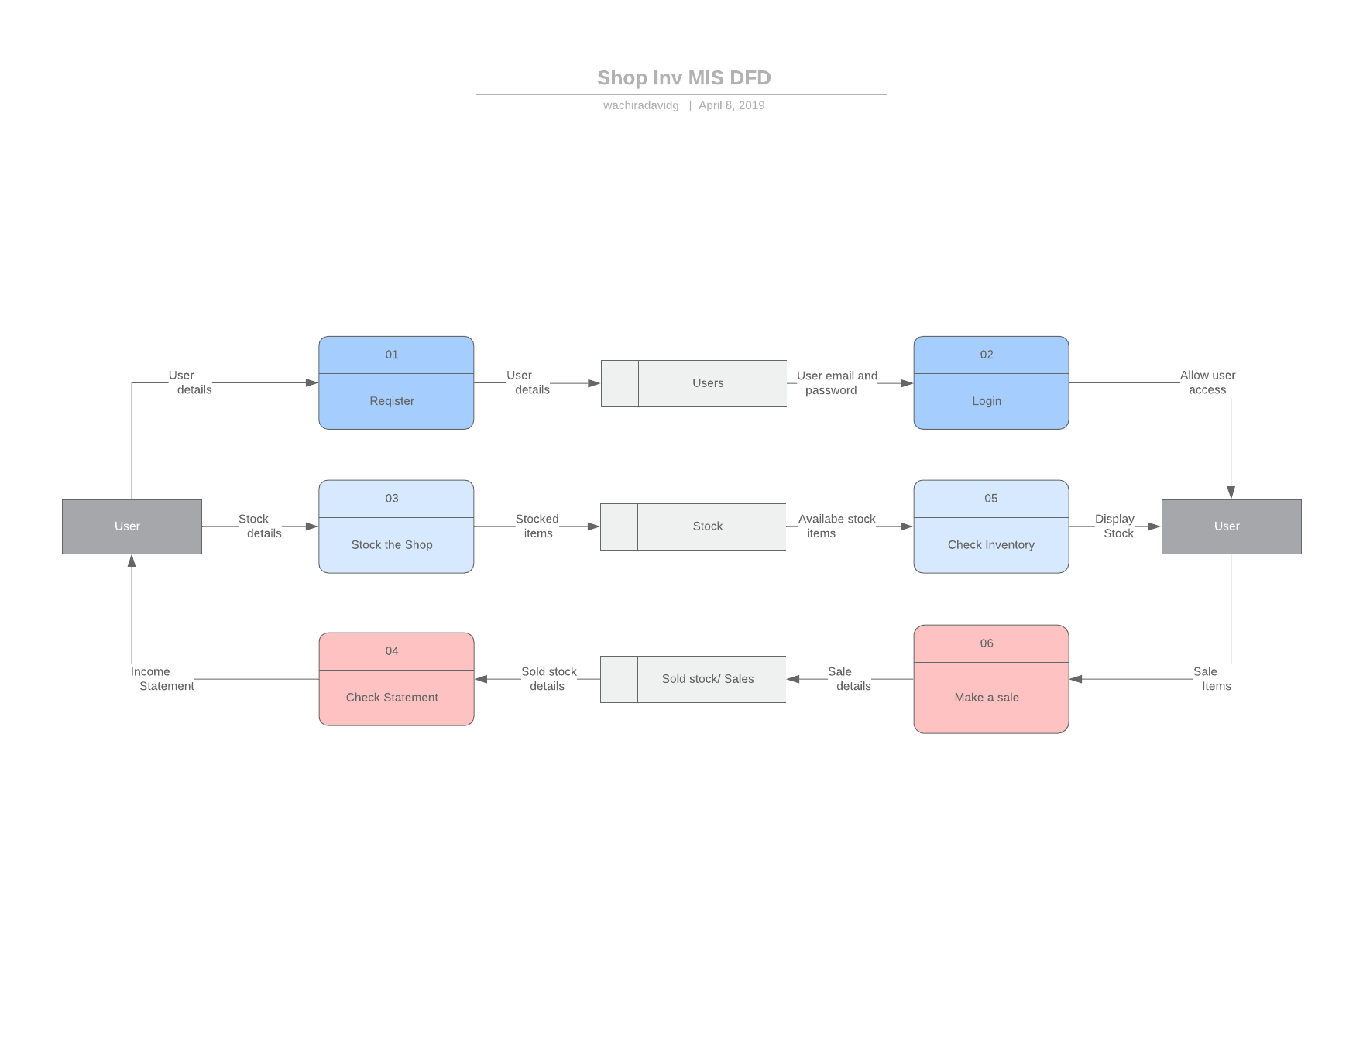

Figure 3: Shop Inventory MIS DFD

### 4.5.3 Use case diagram

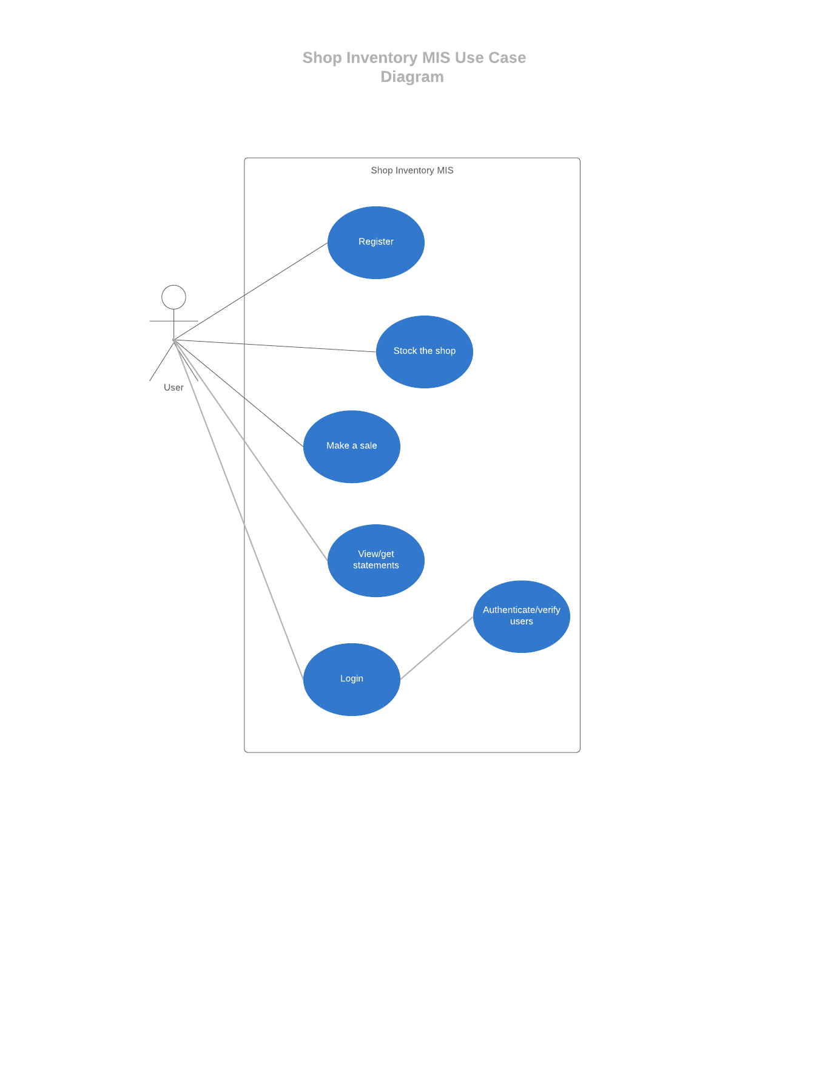

Figure 4: Shop Inventory MIS Use case Diagram

# CHAPTER FIVE: SYSTEM DESIGN

## 5.1 Introduction

**System design** is the process of designing the elements of a system such as the architecture, modules and components, the different interfaces of those components and the data that goes through that system.

The purpose of the System Design process is to provide sufficient detailed data and information about the system and its system elements to enable the implementation consistent with architectural entities as defined in models and views of the system architecture.

This chapter will therefor focus on how the various elements of the system have been designed.

## 5.2 System Design

The Shop Inventory MIS is designed in the 3-tier architecture.

3-tier architecture is a client-server architecture in which the functional process logic, data access, computer data storage and user interface are developed and maintained as independent modules on separate platforms.

The three tiers include; the presentation layer, the application layer and the data layer as shown below.

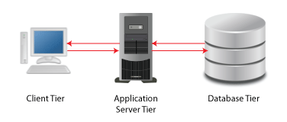

Apache Server.

PHP

MySQL DB

HTML, CSS, JavaScript

Figure 5: Shop Inventory MIS Architecture

## 5.3 Database Design

The Shop Inventory MIS use a MySQL database. The system’s database is called enlighten and it is created and managed by the MySQL relational database management system (RDBMS).

The database has three tables namely, stock, users and sales.

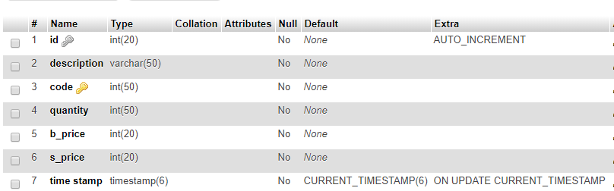

Figure 6: Shop Inventory MIS Stock Table

### 5.3.1 Conceptual Design

This defines the various entities that are in the database together with their attributes.

Table 2: Shop Inventory MIS Conceptual Design

|  |  |  |
| --- | --- | --- |
| **Entity** | **Attributes** | **Data Type** |
| Sales | Id  Item name  Quantity  Buying price  Selling price  Profit  timestamp | Int  Varchar  Int  Int  Int  Int  timestamp |
| Users | Id  First name  Last Name  Email  Contact  Password  Time stamp  type | Int  Text  Text  Varchar  Varchar  Varchar  Timestamp  int |
| Stock | Id  Description  Code  Quantity  Buying price  Selling price  Time stamp | Int  Varchar  Int  Int  Int  Int  timestamp |

### 5.3.2 Logical Design

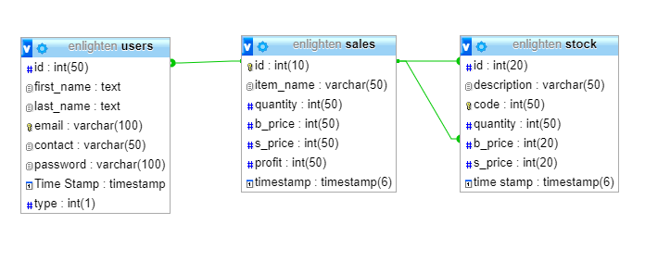

Figure 7: Shop Inventory MIS Logical Design

## 5.4 User Interface

The shop inventory MIS provides a user interface through which users can interact with the system. The system’s UI makes it possible for users to navigate the system and perform the necessary transactions. In a bid to make a good user experience, the UI also gives alerts to users when necessary e.g. “wrong email and password” is displayed in case of a log in error.

The system’s UI is designed with HTML, W3CSS, Bootstrap and JavaScript.

The following are wireframes for some parts of the system.

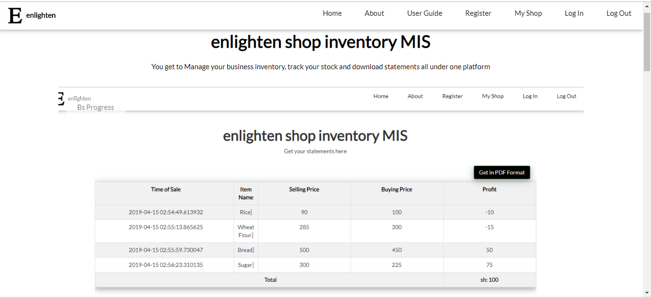

Figure 8: Shop Inventory MIS Home Page

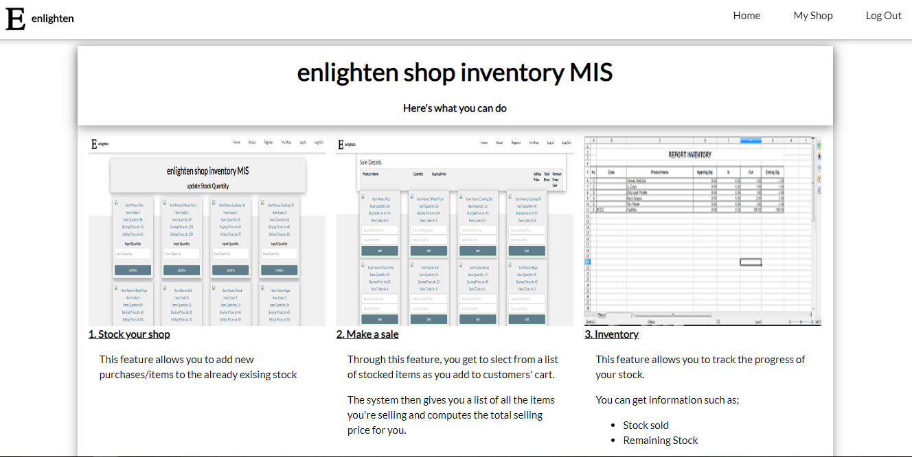

Figure 9: Shop Inventory MIS My Shop Page

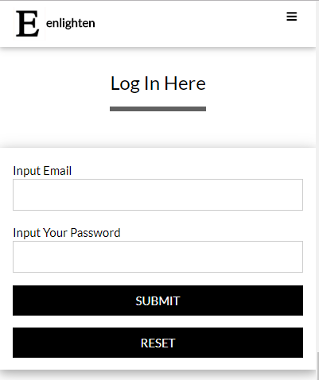

Figure 10: Shop Inventory MIS LogIn Page

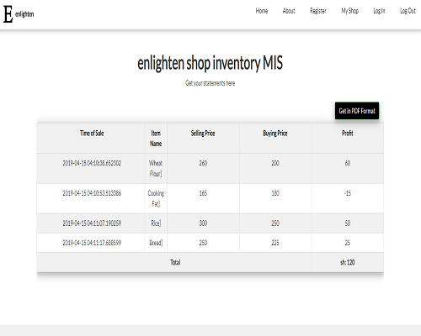

Figure 11: Shop Inventory MIS Profit and Loss Statement

### 5.5 Entity Relationship

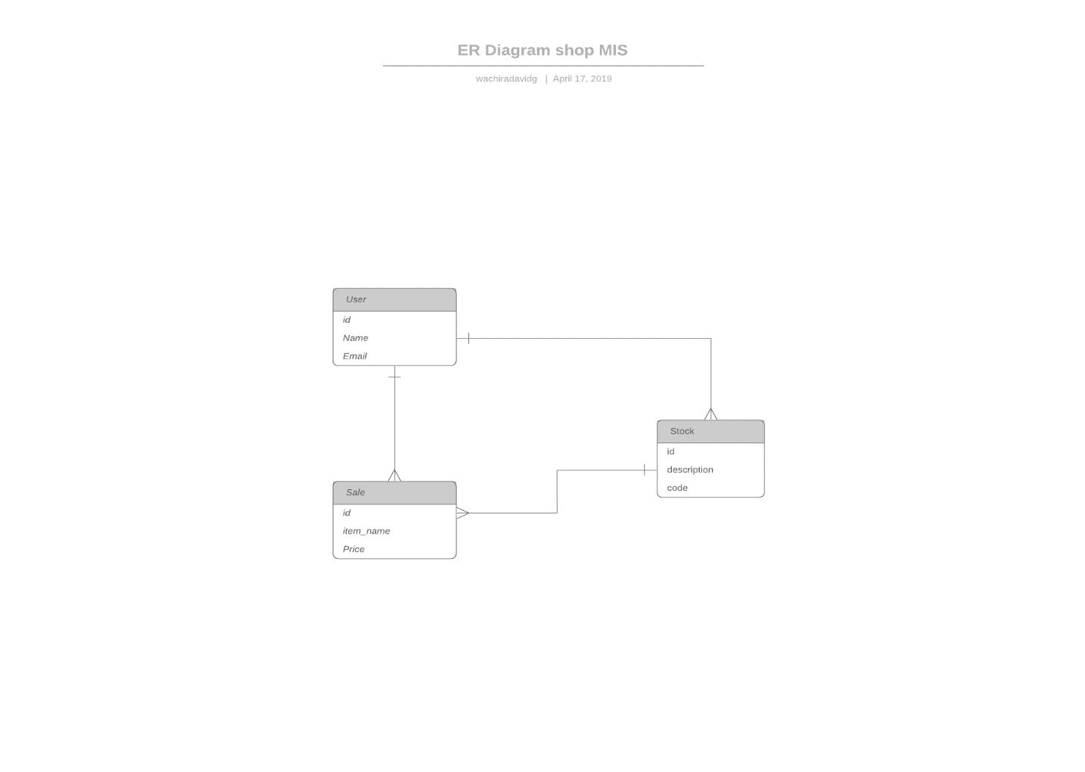

Figure 12: Shop Inventory MIS Entity Relationship

# CHAPTER SIX: SYSTEM IMPLEMENTATION

## 6.1 Tools used for coding and testing

This entails the hardware and software tools used for implementation of the system i.e. the tools used for coding and testing of the system

### 6.2 Hardware requirements

The following are the hardware requirements necessary for the development of the Shop Inventory MIS system.

1. A desktop/ laptop computer. With the following features.

- 4GB of RAM (and above)

- 500GB of ROM (and above)

- Intel core i3 process

1. Unlimited power supply
2. Network hardware. i.e. An android phone for WIFI hotspot tethering.

## 6.3 Software requirements

The following are the hardware requirements necessary for the development of the Shop Inventory MIS system.

1. PHP
2. Java Script
3. W3css
4. Bootstrap
5. Windows 10 Operating System
6. VS Code text editor
7. PHP Storm IDE
8. MySQL Database
9. HTML

## 6.4 Coding

This describes the writing of code to implement the Shop Inventory MIS and the tools required for this.

### 6.4.1 Programing Language

The main programing language used to develop the logical components of the project is PHP together with sql for the database functions. HTML (together with w3CSS, bootstrap and JavaScript) was used for the front end/ User Interface. HTML is the conventional language used for the development of websites and web apps’ User Interface.

### 6.4.2 Database

MySQL database is used for data storage and management for this application.

## 6.5 System test plan

Testing is the process of evaluating a system or its component(s) with the intent to find whether it satisfies the specified requirements or not.

It involves the execution of system in order to identify any gaps, errors, or missing requirements in contrary to the actual requirements.

Various types of tests include; unit testing, functional testing, integration testing, acceptance testing, regression testing and system testing. Tests that have been done on the Shop Inventory MIS are the unit test, system test, integration test, regression test and functional testing.

## 6.6 Test types

### 6.6.1 Functional Test

Functional testing was done on the system to check its compliance with its specified requirements. The application was provided with inputs after which the output results were examined to check compliance with functionality.

### 6.6.2 Unit Test

This test was performed on the various units of the system independently. Its goal was to isolate each part of the system and show that individual parts are correct in terms of requirements and functionality.

### 6.6.3 System Test

System testing tests the system as a whole. Once all the components are integrated, the application as a whole is tested rigorously to see that it meets the specified Quality Standards.

This test was also performed on the system.

### 6.6.4 Integration Test

Integration testing is defined as the testing of combined parts of an application to determine if they function correctly. Integration testing can be done in two ways: Bottom-up integration testing and Top-down integration testing.

Bottom-up integration begins with unit testing, followed by tests of progressively higher-level combinations of units called modules or builds while in top-down integration, the highest-level modules are tested first and progressively, lower-level modules are tested thereafter.

In this case, bottom up integration was used.

### 6.6.5 Regression Test

Whenever a change in a software application is made, it is quite possible that other areas within the application have been affected by this change.

The intent of regression testing is to ensure that a change, such as a bug fix should not result in another fault being uncovered in the application.

Regression testing was used to verify that fixed bugs did not result in violation of other functionalities.

## 6.7 Proposed changes over techniques

System changeover is concerned with the smooth shift from one way of doing things to another and the mitigation of disruption to business activities during the changeover. Two methods will be used: direct changeover and parallel running.

### 6.7.1 Direct Changeover

 Here there’s a single, fixed point where one system stops being used and the new one becomes live. This is the cheapest, quickest and easiest form of system changeover but is also the riskiest – if the system is broken or inefficient, the whole organization suffers.

### 6.7.2 Parallel Running

Both the old and the new systems run side-by-side, using live data, so that project managers can compare the efficiency and reliability of the new system. Once they’re satisfied, the old system is taken offline and the new system becomes fully active and utilized across the organization.

# CHAPTER SEVEN: LIMITATIONS CONCLUTIONS AND RECOMMENDATIONS

## 7.1 Limitations

* Most knowledge on the development tools including languages and IDEs had to be learnt in a short time which caused a time constraint.
* Inadequacy of required financial resources.
* Large project scope which also caused a time constraint.

## 7.2 Conclusion

It is important that shop keepers have a software system for record keeping and inventory tracking.

The Shop Inventory MIS is such a system, it gives the shopkeepers an interface for easy record keeping and analysis of data such as; **stock sold, available stock, amount of profit made, amount of loss made**, etc.

According to (Experian Information Solution Inc, 2018) “**You need good records to monitor the progress of your business. Records can show whether your business is improving, which items are selling, or what changes you need to make. Good records can increase the likelihood of business success.**”

The Shop Inventory MIS provides a cheap and simple way for shop keepers and business owners to meet the above objective.

## 7.3 Recommendations

The following recommendations (when implemented) would make the Shop Inventory MIS an even better i.e. more efficient and effective in meeting user requirements. They include: -

* Development of mobile applications for the system in the various platforms e.g. android, windows etc.
* Implementing offline use of the system.
* Integration of payment methods, especially Mpesa.
* Including Profit and Loss predictions from previous data analysis.

# REFERENCES

Atika School, 2017. *Retail Trade.* [Online]   
Available at: http://www.atikaschool.org/kcse-business-studies-notes/retail-trade-kcse-business-studies-notes  
[Accessed 30 November 2018].

Averkamp, H., 2004. *Financial Accounting.* [Online]   
Available at: https://www.accountingcoach.com/financial-accounting/explanation  
[Accessed 30 November 2018].

Bsiness dictionary, 2018. *Business.* [Online]   
Available at: http://www.businessdictionary.com/definition/business.html  
[Accessed 30 November 2018].

Entrepreneur, 2018. *Kiosks.* [Online]   
Available at: https://www.entrepreneur.com/encyclopedia/kiosks  
[Accessed 30 November 2018].

Experian Information Solution Inc, 2018. *Why keep good business records.* [Online]   
Available at: https://www.businesscreditfacts.com/pdp.aspx?pg=faq-irs6  
[Accessed 29 December 2018].

FinanceOnline, 2019. *10 Best Inventory Management Systems.* [Online]   
Available at: http://www.financeonline.com/top-10-inventrory-management-software-systems/  
[Accessed 6 January 2019].

intuit, 2018. *QuickBooks Accounting Featires.* [Online]   
Available at: https://quickbooks.intuit.com/global/features/  
[Accessed 30 November 2018].

m.k, W., 2006. *Probability Sampling.* [Online]   
Available at: https://socialresearchmethods.net  
[Accessed November 2018].

M.K, W., 2006. *Probability Sampling.* [Online]   
Available at: https://socialresearchmethods.net

Magher, M., 2018. *How to Write a Justification.* [Online]   
Available at: www.education.seattle.com/write-justification-narrative-6609.html  
[Accessed 29 December 2018].

McLeod, S., 2018. *Questionnaire.* [Online]   
Available at: htteps://www.simplypsychology.org/questionnaires.html  
[Accessed 28 November 2018].

Nextar, 2018. *Supermarket POS Software.* [Online]   
Available at: www.nextar.com/examples/supermarket  
[Accessed 29 December 2018].

Owlgen, 2018. *Distinguish between different types of small-scale retailers.* [Online]   
Available at: https://www.owlgen.com/question/distinguish-between-different-types-of-small-scale-retailers  
[Accessed 30 November 2018].

Picincu, A., 2018. *What is Tally Accounting Software.* [Online]   
Available at: https://bizfluent.com/about-7321977-tally-accounting-software-.html  
[Accessed 30 November 2018].

Sincero, S. M., 2012. *Personal Interview Survey.* [Online]   
Available at: https://explorable.com/personal-interview-survey  
[Accessed 28 November 2018].

S, M., 2011. *Software Development Life Cycle Models and Methodologies.* [Online]   
Available at: https://www.google.com/amp/s/melsatar.blog/2012/3/15/software-development-life-cycle-models-and-methodologies/amp/  
[Accessed 29 November 2018].

Taylor, F. W., 1919. *Shopt Managemen.* 1st ed. New York and London: Harper and Brothers Publishers.

Hormozi et al., Manufacturing process improvement: The role of vision systems, Production and Inventory Management Journal. Alexandria: Fourth Quarter 1992, vol. 33, Iss. 4; p. 59, 5 pgs. (seven page printout). *

Tyagi, G., 2000. *6 Stages of Software Development Process.* [Online]   
Available at: www.synaseindia.com/6-stages-of-software-development-process/141  
[Accessed 29 November 2018].

# APPENDIX

## Interesting Codes

This section includes some of the code that make up the main parts of the system. The files include; mypdf.php, sale.php, shop.php and sms.php

### Mypdf.php

<?php

function getData()

{

$output = '';

$con=mysqli_connect("localhost","root","","enlighten");

//fetching from form

$value1 = $_POST['startdate'];

$value2 = $_POST['enddate'];

$startdate = strtotime($value1);

$enddate = strtotime($value2);

$sql = "SELECT MONTH(TIMESTAMP ), item_name, quantity, s_price, b_price,timestamp, TIMESTAMP FROM sales WHERE TIMESTAMP BETWEEN FROM_UNIXTIME($startdate) and FROM_UNIXTIME($enddate)";

$result = mysqli_query($con, $sql);

if(mysqli_num_rows($result) > 0) {

while ($row = mysqli_fetch_array($result)){

$date = strtotime($row["timestamp"]);

$profit = $row["s_price"] - $row["b_price"];

$output .= '<tr>

<td>' . date('F j, Y, g:i a'. $date ) . '</td>

<td>' . $row["item_name"] . '</td>

<td>' . $row["quantity"] . '</td>

<td>' . $row["s_price"] . '</td>

<td>' . $row["b_price"] . '</td>

<td>' . $profit . '</td>

</tr>

';

}

}else{

echo '<script> alert("There were no sales in the selected dates"); window.location= "searchreport.html"</script>';

}

return $output;

}

function getTotal()

{

$out = '';

$con = mysqli_connect("localhost", "root", "", "enlighten");

$sql = "SELECT item_name, s_price, b_price from sales";;

$result = mysqli_query($con, $sql);

if ($result->num_rows > 0) {

$total = 0;

while ($row =mysqli_fetch_array($result)) {

$total = $total + ($row["s_price"] - $row["b_price"]);

$out .= '<tr>

<td colspan="5" ><strong>Total</strong></td>

<th>Sh: ' . number_format($total) . '</th>

</tr>';

}

return $out;

}

}

if(isset($_POST["generate_pdf"])) {

require_once('tcpdf/tcpdf.php');

$obj_pdf = new TCPDF('P', PDF_UNIT, PDF_PAGE_FORMAT, true, 'UTF-8', false);

$obj_pdf->SetCreator(PDF_CREATOR);

$obj_pdf->SetTitle("Financial Statement");

$obj_pdf->SetHeaderData('', '', PDF_HEADER_TITLE, PDF_HEADER_STRING);

$obj_pdf->setHeaderFont(Array(PDF_FONT_NAME_MAIN, '', PDF_FONT_SIZE_MAIN));

$obj_pdf->setFooterFont(Array(PDF_FONT_NAME_DATA, '', PDF_FONT_SIZE_DATA));

$obj_pdf->SetDefaultMonospacedFont('helvetica');

$obj_pdf->SetFooterMargin(PDF_MARGIN_FOOTER);

$obj_pdf->SetMargins(PDF_MARGIN_LEFT, '10', PDF_MARGIN_RIGHT);

$obj_pdf->setPrintHeader(false);

$obj_pdf->setPrintFooter(false);

$obj_pdf->SetAutoPageBreak(TRUE, 10);

$obj_pdf->SetFont('helvetica', '', 11);

$obj_pdf->AddPage();

$content = '';

$content .= '

<h4 align="center">Enlighten Financial Statement </h4><br />

<table border="1" cellspacing="0" cellpadding="0">

<tr>

<th width="30%">Time of Sale </th>

<th width="15%">Item Name</th>

<th width="10%">Quantity</th>

<th width="15%">Selling Price</th>

<th width="15%">Buying Price</th>

<th width="15%">Total</th>

</tr>

';

$content .= getData();

$content .= getTotal();

$content .= '</table>';

$obj_pdf->writeHTML($content);

$obj_pdf->Output('mypdf.pdf', 'I');

}

?>

<!doctype html>

<html lang="en" xmlns="http://www.w3.org/1999/html">

<head>

<title>shop inventory MIS</title>

<link rel="icon" href="images/capture.png" type="image/gif" sizes="16x16">

<meta charset="utf-8">

<meta name="viewport" content="width=device-width, initial-scale=1"

<link rel="stylesheet" type="text/css" href="fonts.css">

<link rel="stylesheet" href="https://fonts.googleapis.com/css?family=Lato">

<link rel="stylesheet" href="https://cdnjs.cloudflare.com/ajax/libs/font-awesome/4.7.0/css/font-awesome.min.css">

<link rel="stylesheet" type="text/css" href="font-awesome.min.css">

<link rel="stylesheet" type="text/css" href="w3.css">

<link rel="stylesheet" type="text/css" href="bootstrap.css">

<style>

html,body,h1,h2,h3,h4 {font-family:"Lato", sans-serif}

.mySlides {display:none}

.w3-tag, .fa {cursor:pointer}

.w3-tag {height:15px;width:15px;padding:0;margin-top:6px}

.product{

border: 1px solid #eaeaec;

margin: -1px 19px 3px -1px;

padding: 10px;

text-align: center;

background-color: #efefef;

}

</style>

</head>

<body >

<!-- Navbar -->

<div class="w3-top">

<div class="w3-bar w3-white w3-card ">

<div class="w3-bar-item w3-left"> <img src="images/elogo.png" style="width:42px;height:42px;border:0;"><strong>enlighten</strong></div>

<a class="w3-bar-item w3-button w3-padding-large w3-hide-medium w3-hide-large w3-right" href="javascript:void(0)" onclick="myFunction()" title="Toggle Navigation Menu"><i class="fa fa-bars"></i></a>

<a href="logout.php" class="w3-bar-item w3-button w3-padding-large w3-hide-small w3-right">Log Out</a>

<a href="#login" class="w3-bar-item w3-button w3-padding-large w3-hide-small w3-right">Log In</a>

<a href="shop.php" class="w3-bar-item w3-button w3-padding-large w3-hide-small w3-right">My Shop</a>

<a href="#register" class="w3-bar-item w3-button w3-padding-large w3-hide-small w3-right">Register</a>

<a href="#about" class="w3-bar-item w3-button w3-padding-large w3-hide-small w3-right">About</a>

<a href="index.html" class="w3-bar-item w3-button w3-padding-large w3-hide-small w3-right">Home</a>

</div>

</div>

<!-- Navbar on small screens -->

<div id="myNav" class="w3-bar-block w3-white w3-hide w3-hide-large w3-hide-medium w3-top" style="margin-top:46px">

<a href="index.html" class="w3-bar-item w3-button w3-padding-large" onclick="myFunction()">Home</a>

<a href="#about" class="w3-bar-item w3-button w3-padding-large" onclick="myFunction()">about</a>

<a href="shop.php" class="w3-bar-item w3-button w3-padding-large" onclick="myFunction()">My Shop</a>

<a href="#register" class="w3-bar-item w3-button w3-padding-large" onclick="myFunction()">Register</a>

<a href="#login" class="w3-bar-item w3-button w3-padding-large" onclick="myFunction()">Log In</a>

<a href="logout.php" class="w3-bar-item w3-button w3-padding-large" onclick="myFunction()">Log Out</a>

</div>

<!-- Content -->

<div class="w3-content" style="max-width:1100px;margin-top:80px;margin-bottom:80px">

<div class="w3-panel w3-center">

<h1><b>enlighten shop inventory MIS</b></h1>

<p>Get your statements here</p>

</div>

<div class="table-responsive">

<br/>

<br/>

<table class="table table-bordered w3-card-4 w3-table-all w3-centered">

<tr class="w3-light-gray">

<th width="30%">Time of Sale</th>

<th width="5%">Item Name</th>

<th width="5%">Quantity</th>

<th width="20%">Selling Price</th>

<th width="20%">Buying Price</th>

<th width="20%">Profit</th>

</tr>

<?php

$con=mysqli_connect("localhost","root","","enlighten");

$sql = "SELECT item_name, s_price, b_price from sales";;

$result = mysqli_query($con, $sql);

$total = 0;

while($row = mysqli_fetch_array($result)) {

$total = $total + ($row["s_price"] - $row["b_price"]);

}

?>

<?php

echo getData();

?>

<tr>

<td colspan="5" ><strong>Total</strong></td>

<th>sh: <?php echo number_format($total); ?></th>

</tr>

</table>

<div class="col-md-12" align="right">

<form method="post" action="mypdf.php">

<div class="w3-section"

<label>Start Date</label>

<input class="w3-input w3-border w3-hover-border-black" style="width:100%;" type="date" name="startdate" required>

</div>

<div class="w3-section">

<label>End Date</label>

<input class="w3-input w3-border w3-hover-border-black" style="width:100%;" type="date" name="enddate" required>

</div>

<input type="submit" name="generate_pdf" class="btn btn-success w3-black w3-card-4" value="Get in PDF Format">

</form>

</div>

</div>

</div>

<!-- Footer -->

<footer class="w3-container w3-padding-32 w3-light-grey w3-center">

<a href="#" class="w3-button w3-black w3-margin"><i class="fa fa-arrow-up w3-margin-right"></i>To the top</a>

<div class="w3-xlarge w3-section">

<i class="fa fa-facebook-official w3-hover-opacity"></i>

<P>&#169;<i>enlighten</i></P>

</div>

</footer>

<script>

//Collapse nav bar

function myFunction() {

var x = document.getElementById("myNav");

if (x.className.indexOf("w3-show") == -1) {

x.className += " w3-show";

} else {

x.className = x.className.replace(" w3-show", "");

}

}

</script>

</body>

</html>

### Sale.php

<?php

session_status();

//connect to server and select database

require_once 'connect.php';

$con=mysqli_connect("localhost","root","","enlighten");

if (isset($_POST["add"])) {

if (isset($_SESSION["sale"])) {

$item_array_id = array_column($_SESSION["sale"], colomns . "product_id");

if (!in_array($_GET["id"], $item_array_id)) {

$count = count($_SESSION["sale"]);

$item_array = array(

'product_id' => $_GET["id"],

'item_name' => $_POST["hidden_description"],

'product_bprice' => $_POST["hidden_bprice"],

'product_sprice' => $_POST["hidden_sprice"],

'item_quantity' => $_POST["quantity"],

);

$_SESSION["sale"][$count] = $item_array;

echo '<script> window.location. "sale.php"</script>';

} else {

// echo '<script> alert("product is already added to sale")</script>';

// echo '<script> window.location. "sale.php"</script>';

}

} else {

$item_array = array(

'product_id' => $_GET["id"],

'item_name' => $_POST["hidden_description"],

'product_bprice' => $_POST["hidden_bprice"],

'product_price' => $_POST["hidden_sprice"],

'item_quantity' => $_POST["quantity"],

);

$_SESSION["sale"][0] = $item_array;

$value1 = $_POST["hidden_description"];

$value2 = $_POST["quantity"];

$value3 = $_POST["hidden_bprice"];

$value4 = $_POST["s_price"];

$value6 = $value2 * $value3;

$value7 = $value2 * $value4;

$value5 = $value4 - $value3;

if ($value4 <= 0){

// echo '<script> alert("Input Selling Price")</script>';

//echo '<script> window.location. "update.php"</script>';

}

$sql = "INSERT INTO sales

(item_name, quantity, b_price, s_price, profit)

VALUES

('$value1]', '$value2', '$value6', '$value7', '$value5')";

if (!mysql_query($sql)) {

die('Error: ' . mysql_error());

}

echo 'the sale has been recorded';

//header("location:home.html");

//updating quantity in stock table

$con = mysqli_connect("localhost", "root", "", "enlighten");

$current_value = $_POST['hidden_quantity'];

$update_quantity = $_POST['quantity'];

$new_quantity = $current_value - $update_quantity;

$code = $_POST['hidden_code'];

if ($update_quantity <= 0) {

//echo '<script> alert("Input Quantity")</script>';

// echo '<script> window.location. "update.php"</script>';

}

$query = "UPDATE stock SET quantity = '$new_quantity' WHERE code = '$code' ";

if (mysqli_query($con, $query)) {

// echo '<script> alert("The record has been updated".$code)</script>';

echo '<script> window.location. "update.php"</script>';

} else {

echo "Error Updating" . mysqli_errno($con);

}

}

}

if(isset($_GET["action"])){

if($_GET["action"] == "delete"){

foreach($_SESSION["sale"] as $key => $value){

if($value["product_id"] == $_GET["id"]){

unset($_SESSION["sale"][$key]);

echo '<script>alert ("product has been removed from sale")</script>';

echo '<script>window.location. "sale.php"</script>';

}

}

}

}

?>

<!doctype html>

<html lang="en">

<head>

<title>shop inventory MIS</title>

<link rel="icon" href="images/capture.png" type="image/gif" sizes="16x16">

<meta charset="utf-8">

<meta name="viewport" content="width=device-width, initial-scale=1"

<link rel="stylesheet" type="text/css" href="fonts.css">

<link rel="stylesheet" href="https://fonts.googleapis.com/css?family=Lato">

<link rel="stylesheet" href="https://cdnjs.cloudflare.com/ajax/libs/font-awesome/4.7.0/css/font-awesome.min.css">

<link rel="stylesheet" type="text/css" href="font-awesome.min.css">

<link rel="stylesheet" type="text/css" href="w3.css">

<link rel="stylesheet" type="text/css" href="bootstrap.css">

<style>

html,body,h1,h2,h3,h4 {font-family:"Lato", sans-serif}

.mySlides {display:none}

.w3-tag, .fa {cursor:pointer}

.w3-tag {height:15px;width:15px;padding:0;margin-top:6px}

.product{

border: 1px solid #eaeaec;

margin: -1px 19px 3px -1px;

padding: 10px;

text-align: center;

background-color: #efefef;

}

</style>

</head>

<body >

<!-- Navbar -->

<div class="w3-top">

<div class="w3-bar w3-white w3-card ">

<div class="w3-bar-item w3-left"> <img src="images/elogo.png" style="width:42px;height:42px;border:0;"><strong>enlighten</strong></div>

<a class="w3-bar-item w3-button w3-padding-large w3-hide-medium w3-hide-large w3-right" href="javascript:void(0)" onclick="myFunction()" title="Toggle Navigation Menu"><i class="fa fa-bars"></i></a>

<a href="logout.php" class="w3-bar-item w3-button w3-padding-large w3-hide-small w3-right">Log Out</a>

<a href="#login" class="w3-bar-item w3-button w3-padding-large w3-hide-small w3-right">Log In</a>

<a href="shop.php" class="w3-bar-item w3-button w3-padding-large w3-hide-small w3-right">My Shop</a>

<a href="#register" class="w3-bar-item w3-button w3-padding-large w3-hide-small w3-right">Register</a>

<a href="#about" class="w3-bar-item w3-button w3-padding-large w3-hide-small w3-right">About</a>

<a href="index.html" class="w3-bar-item w3-button w3-padding-large w3-hide-small w3-right">Home</a>

</div>

</div>

<!-- Navbar on small screens -->

<div id="myNav" class="w3-bar-block w3-white w3-hide w3-hide-large w3-hide-medium w3-top" style="margin-top:46px">

<a href="index.html" class="w3-bar-item w3-button w3-padding-large" onclick="myFunction()">Home</a>

<a href="#about" class="w3-bar-item w3-button w3-padding-large" onclick="myFunction()">about</a>

<a href="shop.php" class="w3-bar-item w3-button w3-padding-large" onclick="myFunction()">My Shop</a>

<a href="#register" class="w3-bar-item w3-button w3-padding-large" onclick="myFunction()">Register</a>

<a href="#login" class="w3-bar-item w3-button w3-padding-large" onclick="myFunction()">Log In</a>

<a href="logout.php" class="w3-bar-item w3-button w3-padding-large" onclick="myFunction()">Log Out</a>

</div>

<!-- Content -->

<div class="w3-content" style="max-width:1100px;margin-top:80px;margin-bottom:80px">

<div class="w3-panel w3-center">

<h1><b>enlighten shop inventory MIS</b></h1>

<p>Click the <b>Sell</b> button to add the item to cart</p>

</div>

<!-- table for sale details -->

<div class="container w3-card-4">

<div style="clear: both"></div>

<h3 class="tittle2">Sale Details</h3>

<div class="w3-responsive">

<table class="w3-table-all w3-hoverable w3-responsive">

<tr class="w3-light-gray">

<th width="30%">Product Name</th>

<th width="10%">Quantity</th>

<th width="110%">Buying Price</th>

<th width="13%">Selling Price</th>

<th width="10%">Total Price</th>

<th width="17%">Remove From Sale</th>

</tr>

<?php

// calculate total price and display sales on cart

if(!empty($_SESSION["sale"])) {

$total = 0;

foreach ($_SESSION["sale"] as $key => $value) {

?>

<tr>

<td><?php echo $value["item_name"]; ?></td>

<td><?php echo $value["item_quantity"]; ?></td>

<td>sh: <?php echo $value["product_bprice"]; ?></td>

<td>sh:<?php echo $value["product_price"]; ?></td>

<td>sh: <?php echo number_format($value["item_quantity"] * $value["product_price"]); ?></td>

<td><a href="sale.php?action=delete&id=<?php echo $value["product_id"]; ?>"><span

class="text-danger">Remove Item</span> </a></td>

</tr>

<?php

$total = $total + ($value["item_quantity"] * $value["product_price"]);

?>

<tr>

<td colspan="4" align="right">Total</td>

<th align="right">sh <?php echo number_format($total); ?></th>

<td></td>

</tr>

<?php

}

}

?>

</table>

</div>

</div>

<?php

//fetching data from the stock table

$query = "SELECT * FROM stock ORDER BY id ASC";

$result = mysqli_query($con,$query);

// check that no of rows is not 0

if(mysqli_num_rows($result) > 0) {

while ($row = mysqli_fetch_array($result)) {

?>

<div class="col-md-3">

<!-- displaying stock -->

<form method="post" action="sale.php?action=add&id=<?php echo $row["id"] ?>">

<div class="product w3-card-4">

<!--Display Products-->

<img src="<?php echo $row[image];?>" class="img-responsive">

<h5 class="text-info"><?php echo 'Item Name: '; echo $row["description"]; ?></h5>

<h5 class="text-info"><?php echo 'Item Quantity: '; echo $row["quantity"]; ?></h5>

<h5 class="text-info"><?php echo 'Buying Price: sh. '; echo $row["b_price"]; ?></h5>

<h5 class="text-info"><?php echo 'Item Code: sh. '; echo $row["code"]; ?></h5>

<input type="text" name="s_price" class="form-control" placeholder="Input Selling Price" required>

<input type="text" name="quantity" class="form-control" placeholder="Input Quantity" required>

<input type="hidden" name="hidden_description" value="<?php echo $row["description"]; ?>">

<input type="hidden" name="hidden_quantity" value="<?php echo $row["quantity"]; ?>">

<input type="hidden" name="hidden_bprice" value="<?php echo $row["b_price"]; ?>">

<input type="hidden" name="hidden_sprice" value="<?php echo $row["s_price"]; ?>">

<input type="hidden" name="hidden_code" value="<?php echo $row["code"]; ?>">

<input type="submit" name="add" style="margin-top: 5px" class="btn btn-success w3-button w3-block w3-blue-grey" value="Sell">

</div>

</form>

</div>

<?php

}

}

?>

</div>

<!-- Footer -->

<footer class="w3-container w3-padding-32 w3-light-grey w3-center">

<a href="#" class="w3-button w3-black w3-margin"><i class="fa fa-arrow-up w3-margin-right"></i>To the top</a>

<div class="w3-xlarge w3-section">

<i class="fa fa-facebook-official w3-hover-opacity"></i>

<P>&#169;<i>enlighten</i></P>

</div>

</footer>

<script>

// Slideshow

var slideIndex = 1;

showDivs(slideIndex);

function plusDivs(n) {

showDivs(slideIndex += n);

}

function currentDiv(n) {

showDivs(slideIndex = n);

}

function showDivs(n) {

var i;

var x = document.getElementsByClassName("mySlides");

var dots = document.getElementsByClassName("demodots");

if (n > x.length) {slideIndex = 1}

if (n < 1) {slideIndex = x.length} ;

for (i = 0; i < x.length; i++) {

x[i].style.display = "none";

}

for (i = 0; i < dots.length; i++) {

dots[i].className = dots[i].className.replace(" w3-white", "");

}

x[slideIndex-1].style.display = "block";

dots[slideIndex-1].className += " w3-white";

}

//Collapse nav bar

function myFunction() {

var x = document.getElementById("myNav");

if (x.className.indexOf("w3-show") == -1) {

x.className += " w3-show";

} else {

x.className = x.className.replace(" w3-show", "");

}

}

</script>

</body>

</html>

### sms.php

<?php

// Initialize the session

session_start();

// If session variable is not set it will redirect to login page

if(!isset($_SESSION['email']) || empty($_SESSION['email'])){

header("location: login1st.html");

exit;

}

?>

<html lang="en">

<head>

<title>shop inventory MIS</title>

<link rel="icon" href="images/capture.png" type="image/gif" sizes="16x16">

<meta charset="utf-8">

<meta name="viewport" content="width=device-width, initial-scale=1"

<link rel="stylesheet" type="text/css" href="fonts.css">

<link rel="stylesheet" href="https://fonts.googleapis.com/css?family=Lato">

<link rel="stylesheet" href="https://cdnjs.cloudflare.com/ajax/libs/font-awesome/4.7.0/css/font-awesome.min.css">

<link rel="stylesheet" type="text/css" href="font-awesome.min.css">

<link rel="stylesheet" type="text/css" href="w3.css">

<style>

html,body,h1,h2,h3,h4 {font-family:"Lato", sans-serif}

.mySlides {display:none}

.w3-tag, .fa {cursor:pointer}

.w3-tag {height:15px;width:15px;padding:0;margin-top:6px}

</style>

</head>

<body >

<!-- Navbar -->

<div class="w3-top">

<div class="w3-bar w3-white w3-card ">

<div class="w3-bar-item w3-left"> <img src="images/elogo.png" style="width:42px;height:42px;border:0;"><strong>enlighten</strong></div>

<a class="w3-bar-item w3-button w3-padding-large w3-hide-medium w3-hide-large w3-right" href="javascript:void(0)" onclick="myFunction()" title="Toggle Navigation Menu"><i class="fa fa-bars"></i></a>

<a href="logout.php" class="w3-bar-item w3-button w3-padding-large w3-hide-small w3-right">Log Out</a>

<a href="#" class="w3-bar-item w3-button w3-padding-large w3-hide-small w3-right">My Shop</a>

<a href="index.html" class="w3-bar-item w3-button w3-padding-large w3-hide-small w3-right">Home</a>

</div>

</div>

<!-- Navbar on small screens -->

<div id="myNav" class="w3-bar-block w3-white w3-hide w3-hide-large w3-hide-medium w3-top" style="margin-top:46px">

<a href="index.html" class="w3-bar-item w3-button w3-padding-large" onclick="myFunction()">Home</a>

<a href="#" class="w3-bar-item w3-button w3-padding-large" onclick="myFunction()">My Shop</a>

<a href="logout.php" class="w3-bar-item w3-button w3-padding-large" onclick="myFunction()">Log Out</a>

</div>

<!-- content -->

<div class="w3-content w3-card-4" style="max-width:1100px;margin-top:80px;margin-bottom:80px">

<div class="w3-panel w3-card-4 w3-center ">

<h1><b>enlighten shop inventory MIS</b></h1>

<p><b>Here's what you can do</b></p>

</div>

<!-- First Photo Grid-->

<div class="w3-row-padding">

<div class="w3-third w3-container w3-margin-bottom">

<a href="stockadmin.php">

<img src="images/stockupdate.PNG" alt="Stock" style="width:100%" class="w3-hover-opacity"><strong>1. Stock your shop</strong>

</a>

<div class="w3-container w3-white">

<p>This feature allows you to add new purchases/items to the already exising stock </p>

</div>

</div>

<div class="w3-third w3-container w3-margin-bottom">

<a href="sale.php">

<img src="images/sale1.PNG" alt="Sell" style="width:100%" class="w3-hover-opacity"><strong>2. Make a sale</strong>

</a>

<div class="w3-container w3-white">

<p>Through this feature, you get to slect from a list of stocked items as you add to customers' cart. </p>

<p>The system then gives you a list of all the items you're selling and computes the total selling price for you.</p>

</div>

</div>

<div class="w3-third w3-container">

<a href="inventory.php">

<img src="images/track.png" alt="Norway" style="width:100%" class="w3-hover-opacity"><strong> 3. Inventory</strong>

<a>

<div class="w3-container w3-white">

<p>This feature allows you to track the progress of your stock.</p>

<p>You can get information such as;

<ul>

<li>Stock sold</li>

<li>Remaining Stock</li>

</ul>

</p>

</div>

</div>

</div>

<!-- Second Photo Grid-->

<div class="w3-row-padding">

<div class="w3-third w3-container w3-margin-bottom">

<a href="searchreport.html">

<img src="images/statement1.PNG" alt="Norway" style="width:100%" class="w3-hover-opacity"><strong>4. My Statements</strong>

</a>

<div class="w3-container w3-white">

<p>This feature allows you to view your statements and download them where need be</p>

</div>

</div>

<div class="w3-third w3-container w3-margin-bottom">

<a href="adverts.html">

<img src="images/advert.jpg" alt="Norway" style="width:100%" class="w3-hover-opacity"><strong>5. Advertice your products

</a>

<div class="w3-container w3-white">

<p>Through this platform, you can also advertice your products via the enlighten website at a very affordable cost.</p>

</div>

</div>

<div class="w3-third w3-container">

<a href="tutorial.html">

<img src="images/tutorial.png" alt="Norway" style="width:100%" class="w3-hover-opacity"><strong>6. System tutorial</strong>

</a>

<div class="w3-container w3-white">

<p>Here, you get a detailed and easy to understand tutorial on how to use the enlighten shop inventory MIS.</p>

</div>

</div>

</div>

</div>

<?php

?>

<!-- Footer -->

<footer class="w3-container w3-padding-32 w3-light-grey w3-center">

<a href="#" class="w3-button w3-black w3-margin"><i class="fa fa-arrow-up w3-margin-right"></i>To the top</a>

<div class="w3-xlarge w3-section">

<i class="fa fa-facebook-official w3-hover-opacity"></i>

<P>&#169;<i>enlighten</i></P>

</div>

</footer>

<script>

// Slideshow

var slideIndex = 1;

showDivs(slideIndex);

function plusDivs(n) {

showDivs(slideIndex += n);

}

function currentDiv(n) {

showDivs(slideIndex = n);

}

function showDivs(n) {

var i;

var x = document.getElementsByClassName("mySlides");

var dots = document.getElementsByClassName("demodots");

if (n > x.length) {slideIndex = 1}

if (n < 1) {slideIndex = x.length} ;

for (i = 0; i < x.length; i++) {

x[i].style.display = "none";

}

for (i = 0; i < dots.length; i++) {

dots[i].className = dots[i].className.replace(" w3-white", "");

}

x[slideIndex-1].style.display = "block";

dots[slideIndex-1].className += " w3-white";

}

//Collapse nav bar

function myFunction() {

var x = document.getElementById("myNav");

if (x.className.indexOf("w3-show") == -1) {

x.className += " w3-show";

} else {

x.className = x.className.replace(" w3-show", "");

}

}

</script>

</body>

</html>